The Royal College
Winter Holiday Homework 2023-24
Class 7th
Dear Parents

Vacations are not only meant to explore the world outside but also are an opportunity to rediscover ourselves while we stay at home. So, embark on a journey of fun and adventure by reading books, exercising, meditating, dancing and channelizing your energy in a positive manner.
The Winter Vacation has begun. To keep our students engaged in fun based learning activities we have compiled a set of activities for the Winter Vacation. You may have to help your child to complete the home-work.
Kindly make sure that your child submits the homework to their respective class teacher/ subject teachers as per the submission dates suggested.

English-
Lyrics Jigsaw
1-Write two popular English songs.( contemporary music or pop music)Jigsaw the lyrics and create your own song.
2- Design a magazine for children aged between 10 to 13 years. Choose an interesting name for your magazine.
Make a colourful cover page. It must have an index. The magazine can comprise of 9 to 10 pages.
Any four - five topics can be chosen out of these listed below-
- Current affairs
- Amazing facts
- Stories
- Jokes
- Poems
- Advertisements
- Scrambled words
Learn & write the following topic in your English holiday homework notebook for your upcoming declamation competition.
Develops your mind: Reading helps you understand the world around you, improves your creativity, and builds your wisdom and thinking capabilities.
Improves your communication skills: Reading improves your vocabulary and develops your communication skills.
Helps you relax: Reading can reduce stress and put you in a better mood.
Helps you concentrate: Reading a few pages every day helps with concentration, which is important for academic classes.
Helps you develop critical thinking skills: Reading can help you learn to analyze situations more effectively.
Helps you learn about different cultures and perspectives: Reading can open up new worlds and experiences.

Hindi-हमारी भाषा (व्याकरण)
पेज नं०- 119, 120, 121, 122, 124, 126, 129
क्रियाकलाप- “रानी लक्ष्मीबाई” की जीवनी लिखो और उनका एक चित्र भी बनाओ।

Mathematics-
Activity 1- Draw robot on a grid paper using art of geometry and then calculate its area and perimeter.
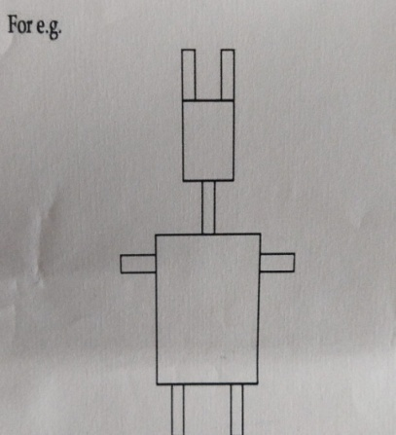
Activity 2- Collect any 5 decimal numbers like temperature data from newspaper. Paste those numbers and then convert decimal into fraction.
Newspaper cutting | Decimal | Fractions
Do the following chapters from Learning composite book:
Algebric expression: Self practice 5A, 5B, 5C.
Percentage and its application: Self practice 8A, 8B, 8D.
Perimeter and area: Self practice 14A, 14B

Science-
Activity 1-
Waste management in environment
Household hazards waste- It has a potential threat to public health and environment. They can be highly reactive/toxic in nature. These are home generated waste that should not be disposed off into a landfill. Example- drain cleaners, oil paints, motor oil, batteries, fluorescent lamps, medical waste, electronic waste, etc. Spread awareness about this waste in your society by designing a colourful poster highlighting these waste and safety methods.
Activity 2-
Understanding Air Pollution
With the advent of technology in the field of transportation, major harm is being caused to our environment on a daily basis. Air Pollution has become a threat to not only the environment but also to the health of all living organisms.
Dear students, the science project this year focuses on getting a better understanding of this prevalent environment threat and also to find solutions to the problems which we face due to the presence of excess pollutants in the air that we breathe.
Collect information on the following and present in on an A4 size sheet (5 to 8 sheets)
1. What is AQI?
2. How do AQI levels everyday during winter and mention the days that it was highest and lowest along with a suitable reason for the change in AQI level.
3. Name some common air pollutants.
4. Which is the most polluted as well as least polluted city in India?
5. List some solutions to curb air pollution.
Social Science-
- Environment is what we see around us compare environment to Haryana and Manipur on the basis of trees birds animals landscape and tourist destination and right in the tabular form on the A4 sheet.
- Name the festival of Nagaland and locate the major tribes of Rajasthan and Nagaland giving a brief introduction of their cuisine and culture and folk tales.
- Show the following in the outline political map of India
- Bengal
- Punjab
- Surat
- Ajmer
- Arabian Sea
- Gujarat
- Bay of Bengal
- Delhi
- Kerala
- Lakshadweep
- Indian ocean
- Andaman Nicobar
Write one paragraph each on the following topic
Indian languages
Indian food
Indian festival
- Drop poster wish shows the culture aspects of Lakshadweep Island
Or
Make a project regarding all the aspects of hot and cold desert

For any query you can call to Miss. Shivangi on this number +918941845010 only between 10.30 am to 11.30am.

